In order to set up the payment gateway, specific information is required depending on the type of gateway requested.

PayPal Website Payments Standard:

Email address associated with the PayPal account

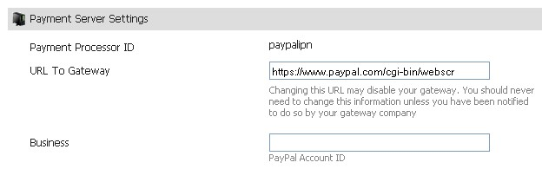
- PayPal Website Payments Pro:

API Username

API Password

Certificate File

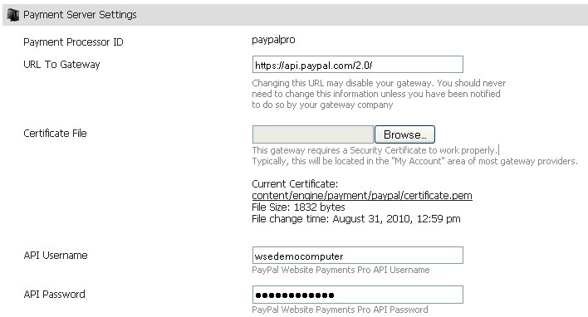

- 2Checkout.com

Sid
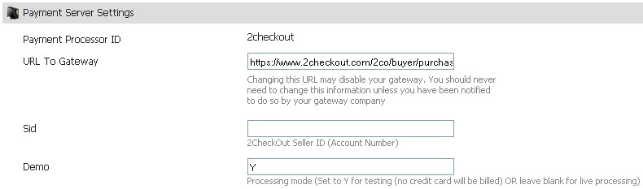
- Amazon Simple Pay

Access Key

Secret Key

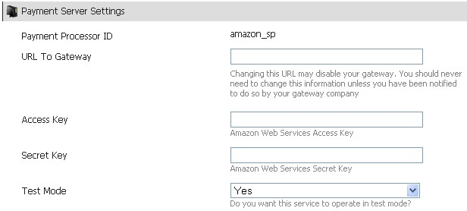

- Authorize.Net AIM 3.0

Login

Password

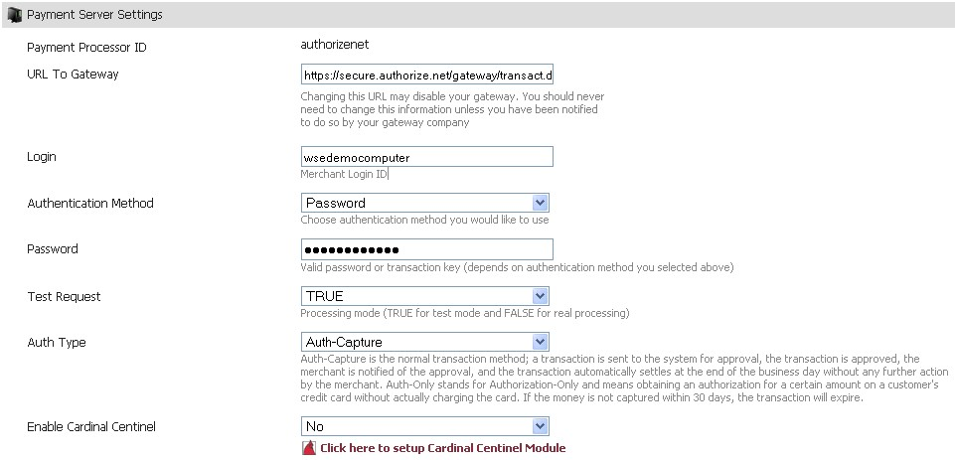
- Authorize.Net AIM 3.1

Login

Transaction Key
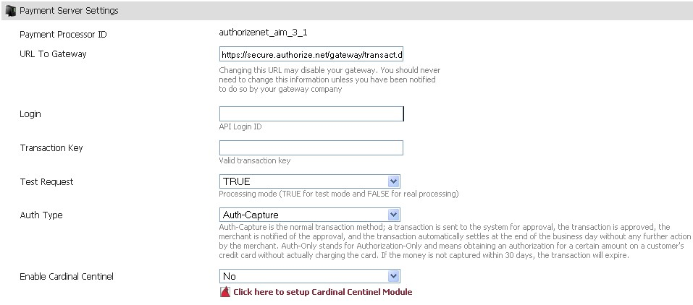

- Authorize.Net CP 1.0

Login

Transaction Key
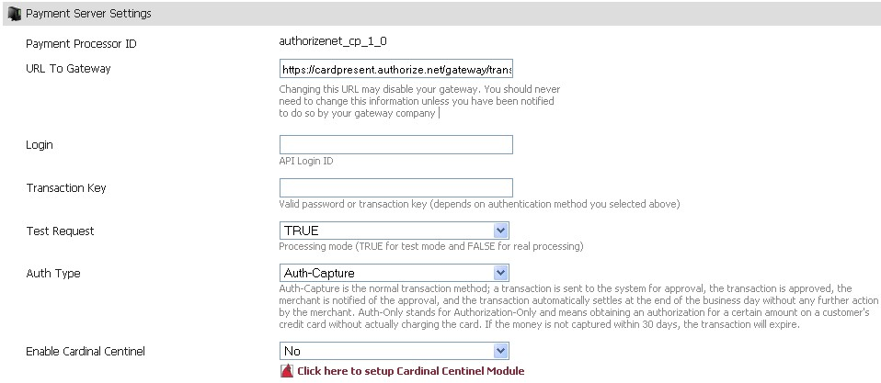

- Authorize.Net eCheck.Net

Login

Transaction Key

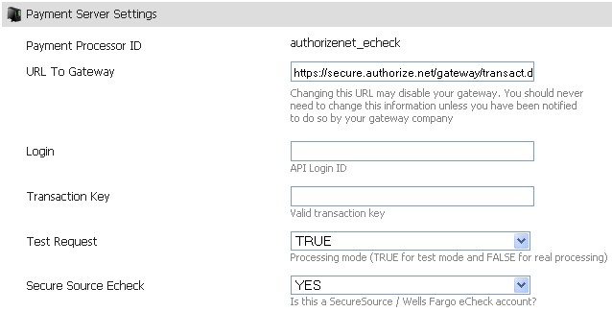
- Chase Paymentech Orbital

Connection Username

Connection Password

Transaction Routing Definition

Merchant Account Number

Terminal ID
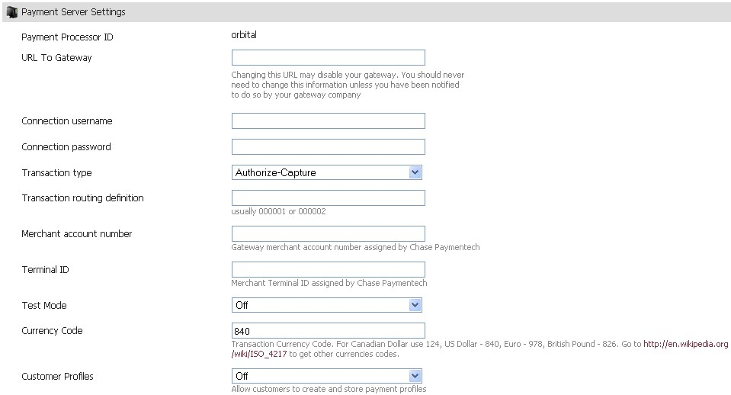
- DataCash

VTid

Password
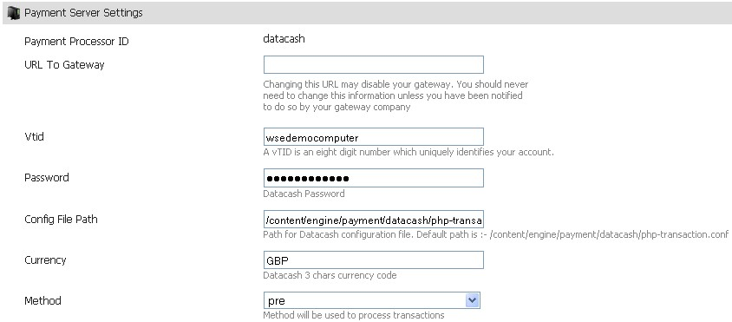
- DirectOne

Vendor Name
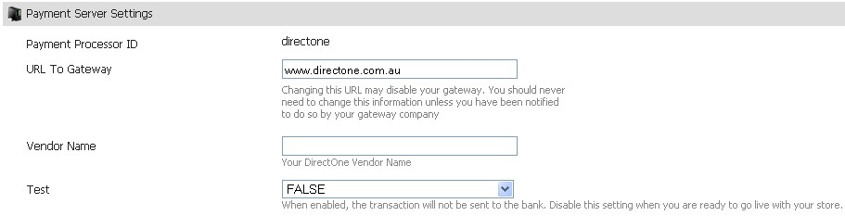
- EC Suite

Auth Key

Merchant Id

Terminal Id
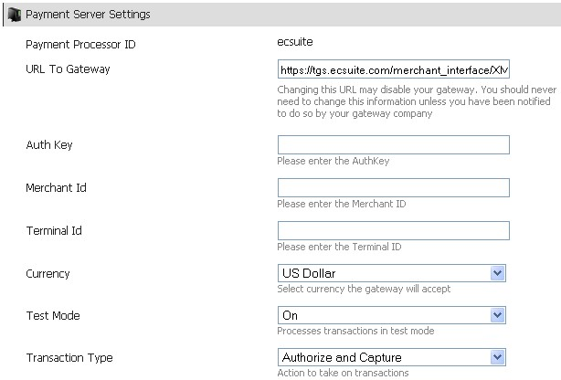

- Echo-Inc.com

Merchant ID

Merchant Pin

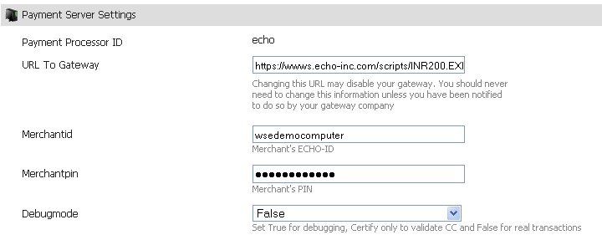
- FastTransact.com

Account ID
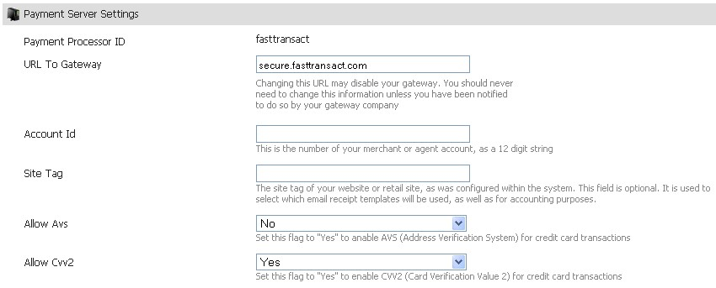

- First Data / LinkPoint.com

Certificate File

Merchant Store Number
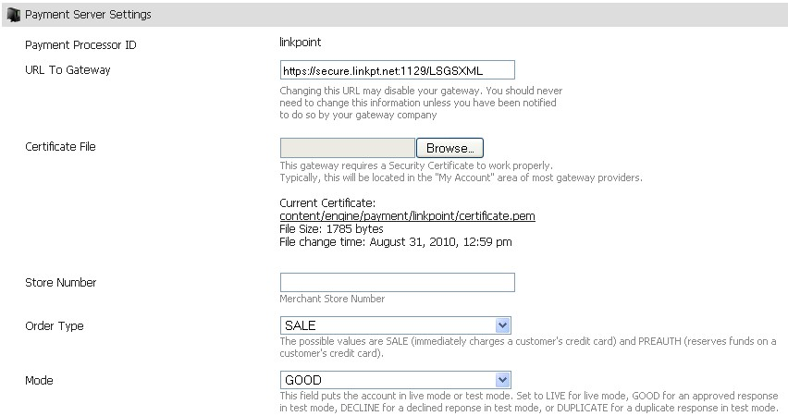

- Google Checkout:

Merchant ID
- HSBC-CPI

Hash Key

Storefront ID
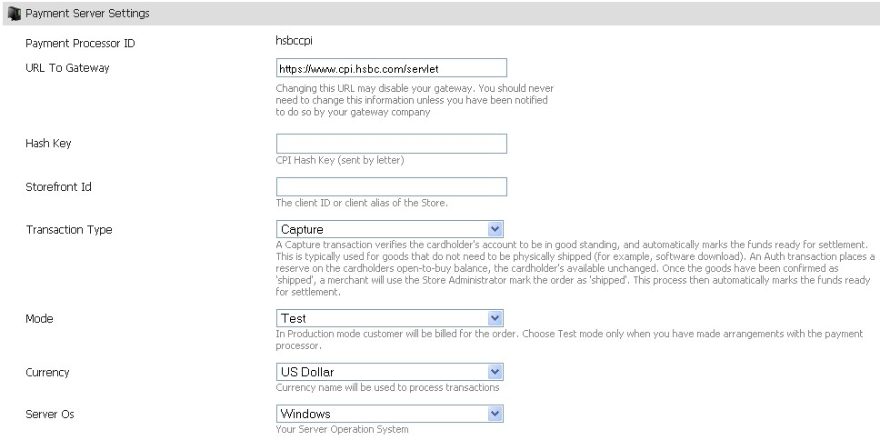
- Intuit Payment Services

App Login

App ID

Connection Ticket
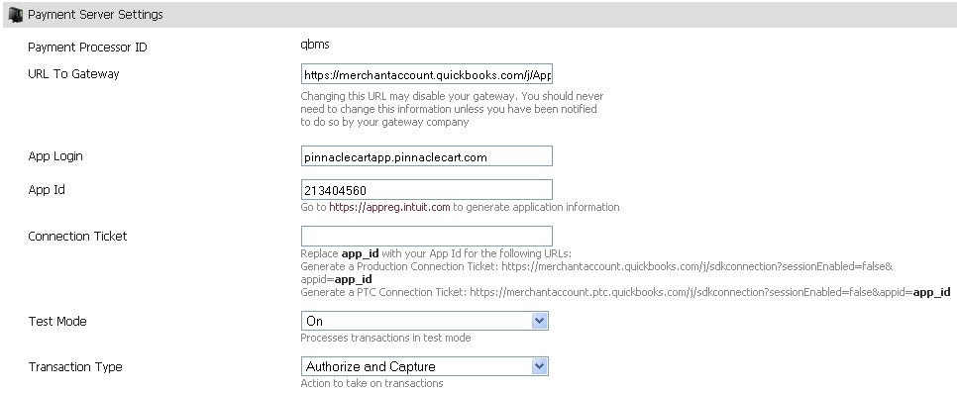

- iTransact.com

Customer Code
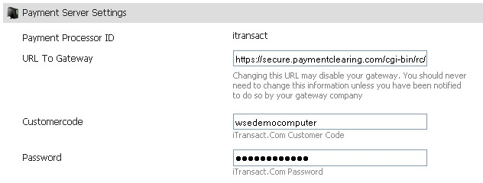

- Moneris.com

Store ID

API Token
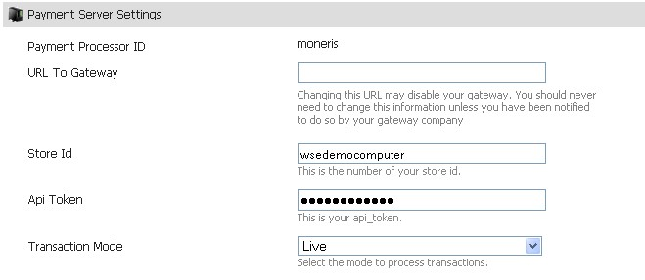

- NTPNow.Com

Ntpnow ID

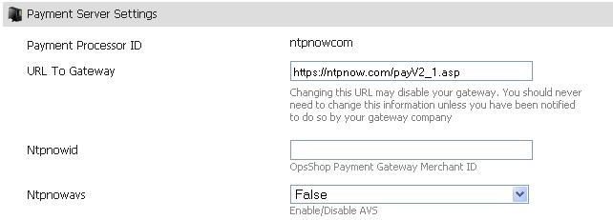

- Moneybookers Quick Checkout

First Name: of the merchant moneybookers.com account to Activate Quick Checkout

Last Name: of the merchant moneybookers.com account to Activate Quick Checkout

Email ID

Customer ID

Secret Word

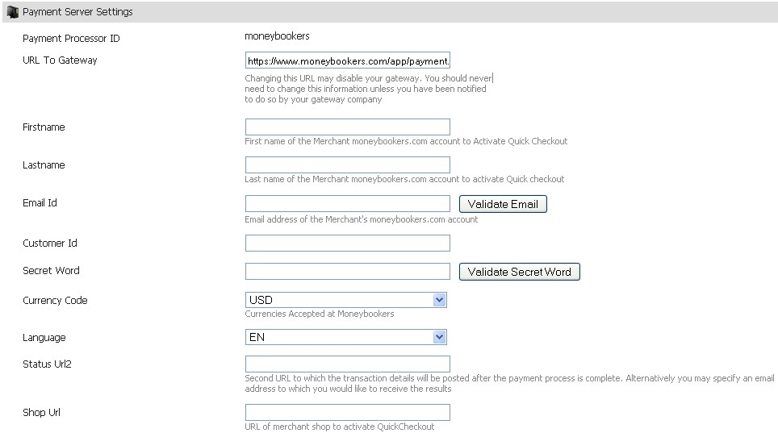

- NetBilling.com

Account ID
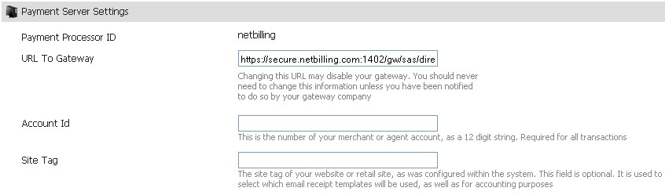

- Payjunction

DC Logon

DC Password
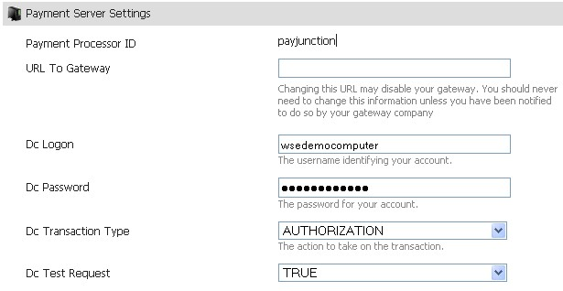
- PayLeap

API Login ID

Transaction Key
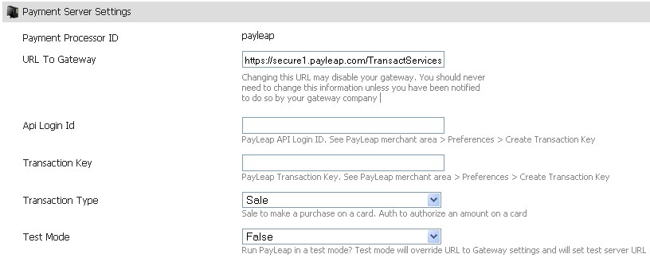

- PayPal Express Checkout

Certificate File

Email

Username

Password
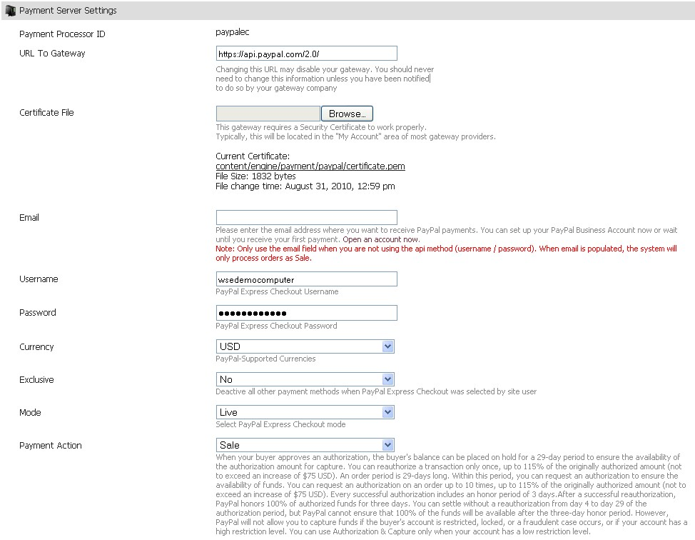

- PayPal PayFlow Link

Login
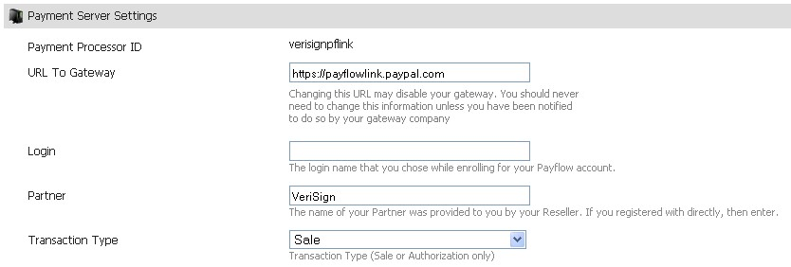
- PayPal Payflow Pro

Username

Vendor

Password
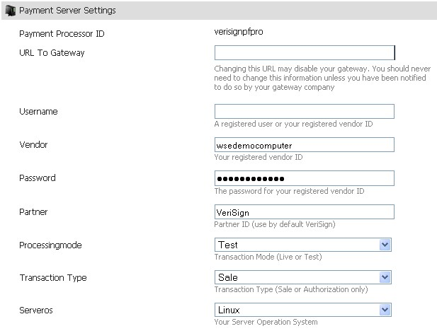
- PayPal Website Payments Pro (Payflow Edition)

User

Vendor

Password
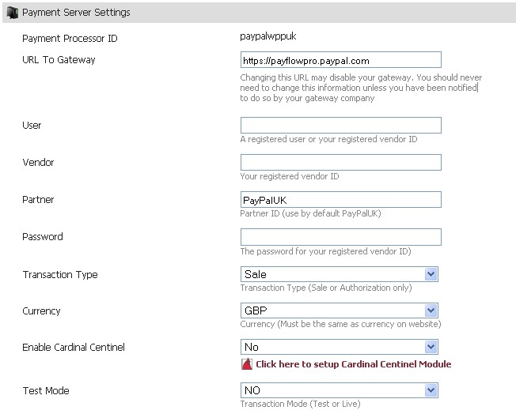

- Protx.com

Vendor

Password

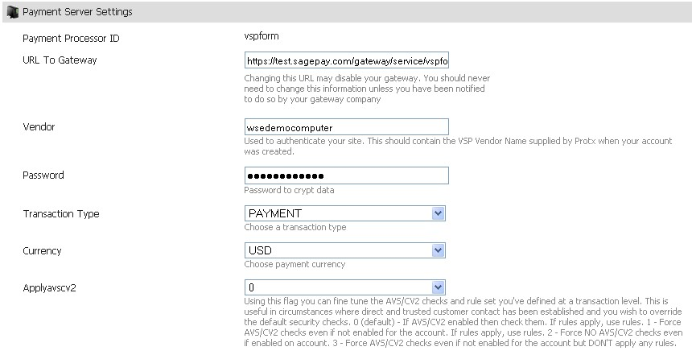
- PsiGate.com

Store ID

Pass Phrase
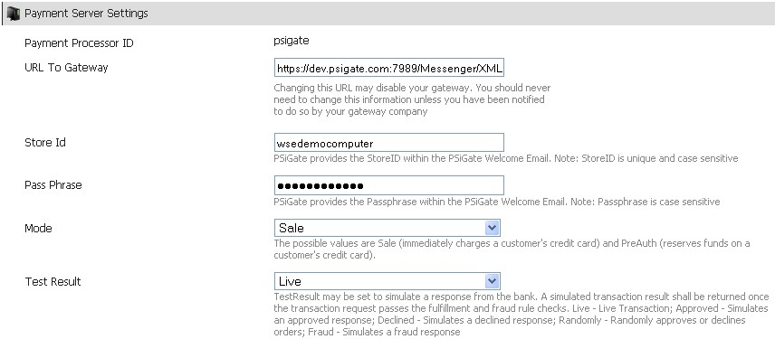

- Secure Hosting

SH Reference

Checkcode

Password
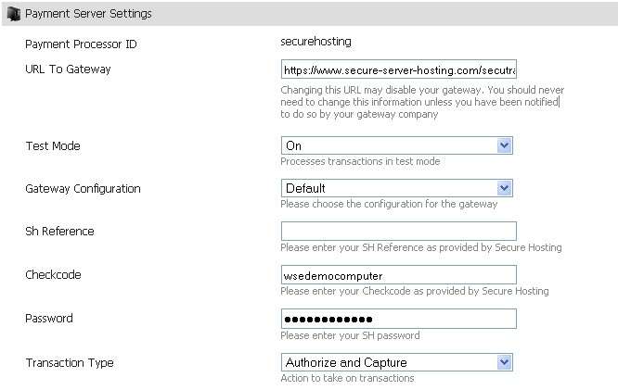
- WorldPay.com

Inst ID
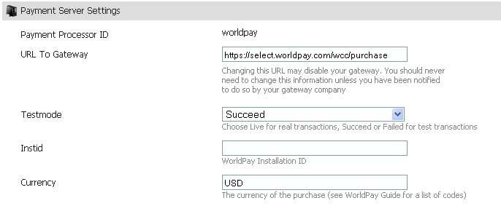

- Shift4.com

Login

Password

SN Number

Merchant

Vendor

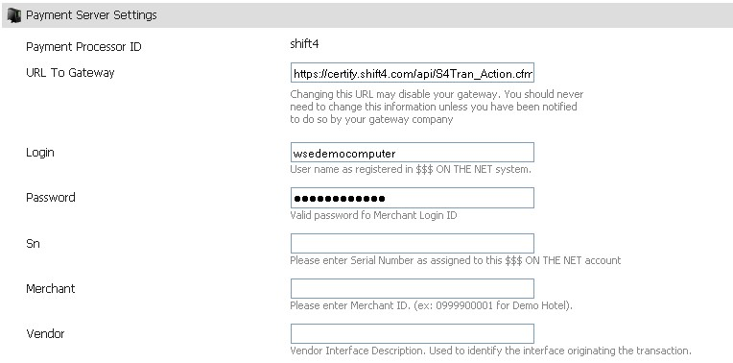
- Transaction Central

Merchant ID

REGKey
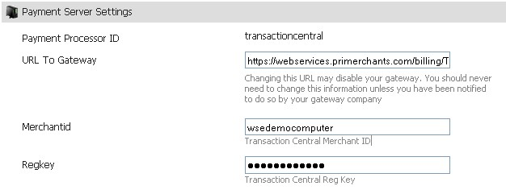

- Secure Trading Payment Pages

Merchant Site Reference

Password

Merchant Email Address
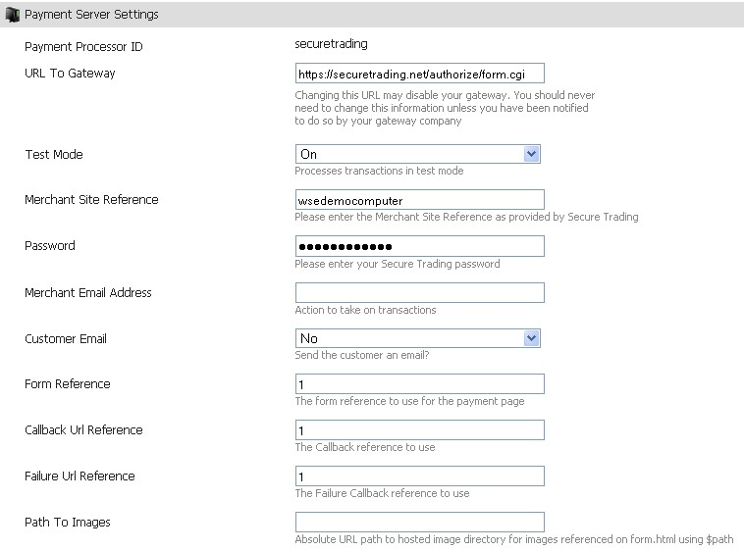

- SecurePay (Australia) SecureXML

Merchant ID

Merchant PW
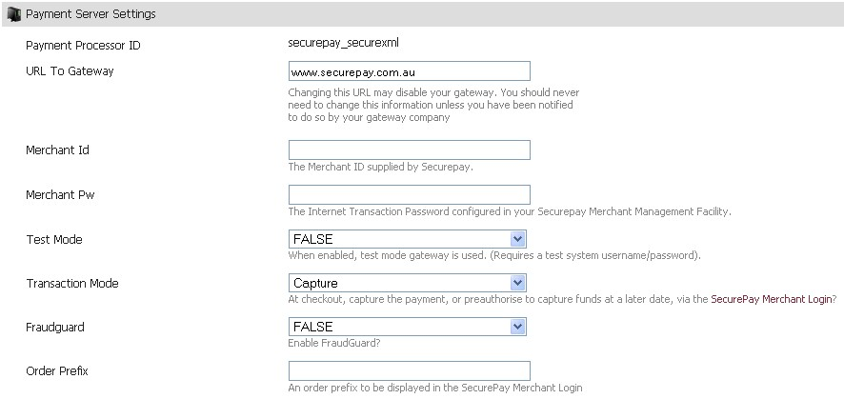

- USAepay

Key

Pin
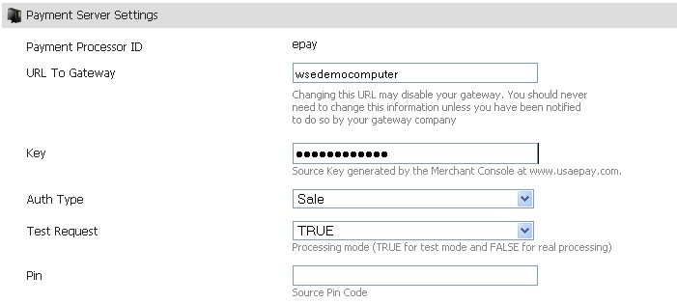

- ViaKLIX

Merchant ID

USER ID

Pin
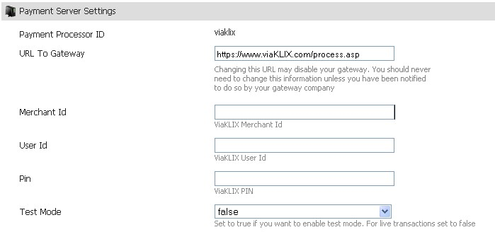

- Virtual Merchant

Merchant ID

User ID

Pin

